 | OSP Social Media Resource  Module 2: Creating Your Marketing Materials

In this Ontario Skills Passport (OSP) Social Media Resource module, you will:
- Create a great bio to make a great impression.
- Create online content that genuinely reflects who you are while showcasing your transferable Essential Skills and work habits. This can help you stand out in the crowd of people who may be applying for the same job, academic program or volunteer opportunity as you are.
- Collect great social proof of your skills and accomplishments using OSP tools and resources such as OSP Work Plans and OSP Community Involvement Worksheets.

This module can help you find meaningful answers to the education and career/life planning inquiry questions. These two questions are particularly relevant to this module: Who am I? What are my opportunities? | 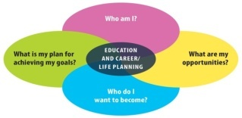

Work Smart: Stay Safe
Social media is a great tool to expand your opportunities for post-secondary education, volunteer work and employment. But like any tool it is important to take precautions to stay safe while you are using it. Before beginning these modules:

- Make sure your parents know what websites you are using before you start any social media networking.
- Check with your teacher or guidance counsellor for any additional school board policies that may apply in your area.
The Kids Help Phone website has some great online safety tips.

Check out the image of the Social Media Landscape below. How many of the different types of social media shown below do you use?

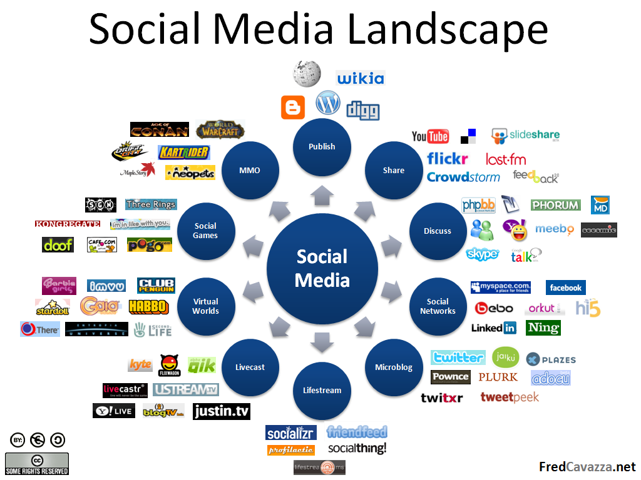

Social media is a great way to show your friends, family, teachers, employers, and volunteer organizations, your skills through the content you create. You have so many options to express your passions and creativity.
However, the social media landscape is a crowded space; every social media website has a different culture of sharing and interacting. This is important to know when you decide which social media websites you want to use.
It is also important to be aware that each social media website has its own “privacy policy”.
Go to the next page to find out more.

Most websites now have privacy policies that describe what kind of information the site collects from you, how it is stored and used, and who it is shared with. However, just because a site has something called a "Privacy Policy" does not mean that the site protects your privacy.
But it’s private!
Yes, there are privacy settings on almost all social media but you can’t control one of your “friends” sharing something you meant to stay private.
Think it doesn’t matter? Check out the story here of the student who lost his scholarship because of what he tweeted.

Even if you understand a site’s privacy policy it can change often so make sure you check regularly for what the policy covers.

The basic rule is, if you want something to be private, don’t put it on the Internet.

Are you ready to start creating your own social media marketing tools? The next section will show you how to create a great bio to make a great impression.
Great Bios Make Great Impressions

Bios – short for biographies – are a short summary of a person’s life. In workplaces they are often used to:
- Introduce a new employee to the rest of the staff
- Feature high profile staff members on a company Website or newsletter
- Highlight an award recipient, special guest, or speaker
- Showcase an author at the end of an article or on the back of a book
- Emphasize the accomplishments and expertise of a leader or celebrity
What makes a great bio?
A bio is a short explanation of who you are and a summary of the important things you have accomplished so far that you want to highlight. That could be anything from playing on a sports team, winning an award, passing your level 7 piano exam, volunteering for charity or designing your own t-shirt line.
A bio is not a summary of everything you have done in your life. It is a short, clear introduction; stick to the highlights and make sure that everything you write is 100% true.
You bio tells the reader:
- What is important to you
- What you want to be known for right now
- What past experience you have
- What Essential Skills and work habits you have

When building your bio, remember to review your OSP Tracker, OSP Work Plan and other OSP records. They include important information on how you have demonstrated your Essential Skills and work habits - this is great evidence of your accomplishments! These are transferable skills you bring with you to every new opportunity, including further education, training, the community and the workplace.

Tips for Writing a Great Bio
Be Strategic!
If you are not sure what to write imagine what future employers might think when they read it.
First impressions matter!
Check spelling and grammar
Do not use slang
Do not use obscenity
Showcase your Essential Skills and work habits
Be creative
Be positive
Tell the truth
Show

- Your opening sentence should include your name and should grab the attention of your audience and make them want to learn more about you.

- In your next sentence, you can share that you’re a student, your work title such as a cashier and/or reference the team/clubs you are part of.

- Add no more than three additional accomplishments and any other information about your other hobbies, interests or everyday life.

- Don’t be afraid to share some of your personality. Write it in a style that feels like you are having a conversation with the readers. Be sure you don’t give out personal information, such as your address.

- Most bios are written in third person using “she/he”, instead of “I”; especially when they are going to be used to introduce you in a formal setting like an awards ceremony or on a company Website. However, that is not a hard rule, especially when using it on a social media profile. Many people choose to write their social media bios in the first person tense because it seems more personal and direct. But the choice is yours.

Here’s an example:
Short, sweet and to the point, is the secret formula of award winning, short-story author and spoken word artist Phil Mowbray. This 15-year-old writing wizard is also extremely busy as the backup point guard for his high school basketball team. Phil spends his summers as a Camp Counsellor working with wildly energetic 5 year olds who think they can outrun him. He likes making chocolate chip cookies, Marvel comics and trying his big sister’s patience. To read some of his work, visit his blog www.Websiteaddress.com or follow him on Twitter.

Use the worksheet on the next page to describe the Essential Skills and work habits that are illustrated in Phil’s bio. You may want to compare your ideas with a partner.
Describe the Essential Skills and Work Habits in Phil’s Bio
- Identify the Essential Skills and work habits Phil chose to highlight in his bio.
- Describe how he demonstrated each of these Essential Skills and work habits.
OSP Icon | Essential Skill | Describe how Phil demonstrated the skill |  |  | OSP Icon | Work Habit | Describe how Phil demonstrated the work habit
 | Reading Text |  |  |  |  | Working Safely
 | Writing |  |  |  |  | Teamwork
 | Document Use |  |  |  |  | Reliability
 | Computer Use |  |  |  |  | Organization
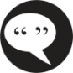 | Oral Communication |  |  |  |  | Working Independently
 | Money Math |  |  |  |  | Initiative
 | Scheduling or Budgeting and Accounting |  |  |  |  | Self-advocacy
 | Measurement and Calculation |  |  |  |  | Customer Service
 | Data Analysis |  |  |  |  | Entrepreneurship
 | Numerical Estimation |  |  |  | Skillszone.ca
  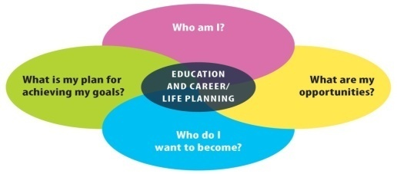 | 
 | Job Task Planning and Organizing
 | Decision Making
 | Problem Solving
 | Finding Information

Describe the Essential Skills and Work Habits in Phil’s Bio Answer Key
- Identify the Essential Skills and work habits Phil chose to highlight in his bio.
- Describe how he demonstrated each of these Essential Skills and work habits.
OSP Icon | Essential Skill | Describe how Phil demonstrated the skill |  |  | OSP Icon | Work Habit | Describe how Phil demonstrated the work habit
 | Reading Text | Phil reads comics. |  |  |  | Working Safely | Phil needs to keep safety in mind as he works with 5-year olds at camp.
 | Writing | Phil demonstrates writing skills as a short-story artist and blogger. |  |  |  | Teamwork | As a member of a basketball team, Phil showed he is a team player.
 | Document Use |  |  |  |  | Reliability | Phil shows he is reliable when he shows up for his job on time.
 | Computer Use | Phil demonstrates computer use skills as a blogger. |  |  |  | Organization | Phil has to keep himself organized to juggle school, work and hobbies.
 | Oral Communication | As a spoken word artist, he demonstrates oral communication skills. |  |  |  | Working Independently | Phil shows he can work independently when he independently maintains his own blog.
 | Money Math |  |  |  |  | Initiative | Phil took the initiative to start his own blog.
 | Scheduling or Budgeting and Accounting | Phil uses his scheduling skills to deal with any conflicts that come up in his busy schedule. |  |  |  | Self-advocacy
 | Measurement and Calculation | Phil uses his measurement and calculation skills every time he makes his favourite chocolate chip cookies. |  |  |  | Customer Service | Phil has demonstrated he has customer service skills through his work as a camp counsellor.
 | Data Analysis |  |  |  |  | Entrepreneurship | He is entrepreneurial when he comes up with new ways to try his sister’s patience! OK … maybe not a good example!
 | Numerical Estimation |  |  |  | Skillszone.ca
 | Job Task Planning and Organizing | As a camp counselor, Phil needs to plan his day so he has enough activities for the kids.
 | Decision Making
 | Problem Solving
 | Finding Information

Write Your Own Bio
Now it is your turn! In this activity you are going to write your own bio. Follow the steps below and use the Create Your Own Bio Template on the next page to help organize your research.
Even though you are writing an online bio, do this work off line so that you don’t accidently post it before you are finished.
STEP 1: | Start by completing the Create Your Own Bio Template. Add as much information as you can think of. Don’t worry if you think it is too long. You will edit the content later to highlight what is most important.
STEP 2: | Review your OSP Work Plan, OSP Tracker and other OSP records to see how you have demonstrated your Essential Skills and work habits. Reflect on how these skills transfer to other contexts.
STEP 3: | Review your work and select the top three skills and accomplishments you would like to include in your bio. Think about your audience and how that will affect your choices and the tone of your writing.
STEP 4: | Decide on the order you want to share the information. Sometimes you want the most important information first; sometimes you want that to be the last thing the reader sees so they remember. You can always change the order later.
STEP 5: | Decide what tense you are going to write in. (1st person: I went to...; 3rd person: Kerry went to...)
STEP 6: | Write your first draft. Don’t worry too much about being funny or clever at this point.
STEP 7: | Read it aloud to yourself. How does it sound? If you stumble or trip over any of the sentences try to edit it until it becomes a smooth read.
STEP 8 | Read your draft aloud to a partner and ask for feedback. You may be surprised how many people say that they learned something new about you from your bio.
STEP 9: | Incorporate the feedback and write another draft.
STEP 10: | Repeat Steps 8 and 9 until you are pleased that your bio is an accurate reflection of who you are. This will likely take awhile before you are happy with it – don’t give up!

Create Your Own Bio Template | 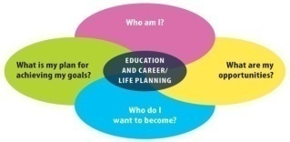
Date: __________________________
Use this template to gather and record the information you need to write an effective bio. Remember, your bio will not include everything about you but doing this research first is important so that you don’t leave anything important out. If you don’t have something for every category, don’t worry. You will build and change your bio as you gain more experience.
- Name:
- Jobs:

- Hobbies:

- Volunteering:

- Interests:

- Languages Spoken:
- Accomplishments:

- Your Essential Skills:

- Your work habits:

- Other skills and/or certifications:

Great Content Gets You Noticed
Did You Know?
Every 60 seconds there are:
1,500 blog posts made
3,600 photos uploaded to Instagram
600 hours of video posted to YouTube
90,000 tweets tweeted
79,000 Facebook posts made

So, how will you stand out and get noticed?
Now that you have created a great bio, the next step is to create great content that gets you noticed.
Creating content is a wonderful way to build your portfolio and showcase your transferable Essential Skills and work habits.
In this activity, you will learn more about the different types of digital content you could create and get ideas and advice to help produce your own content.
When you are ready to create Internet content, your options are wide open. You are not limited to just writing articles. There are several digital mediums to choose from. You can shoot videos, record podcasts, snap photo essays, design graphics, Photoshop pictures, create Websites and much
more.
Creating content can also help you stand out in front of potential employers and attract new opportunities. But, in order to get noticed, your content has to be valuable to your target audience. It also has to be appropriate so that you don’t get noticed for the wrong reasons.
In the next few pages, you will get a chance to look at some content that “Alyssa” has created. She made some mistakes but not too worry … she also got some ideas on how to fix them.

Go to the next page to check out Alyssa’s Social Media Makeover.

“Alyssa’s” Social Media Makeover

“Alyssa” has created a social media profile to make it easier for volunteer organizations, post-secondary admissions departments and employers to find out more about her when she applies for opportunities with each of them.

The before column shows some common mistakes people make when setting up a profile. The after column incorporates suggestions from our social media experts. Are you guilty of any of the same mistakes? Which profile do you think will do a better job of helping “Alyssa” reach her goals?

Section | Before |  |  | After |  |  |  | Why the makeover?
Profile Picture |  |  |  | 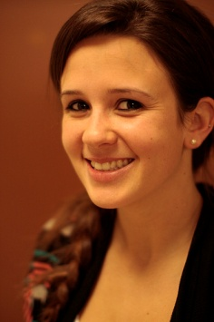 |  |  |  | Dogs are cute but people will want to see Alyssa's face if they are considering her for a position.  Whether you are applying for college, a volunteer position, a job, or running for student council, it's a good idea to use a close-up picture with a warm and friendly expression.
Location | To infinity and beyond! |  |  | Kitchener, Ontario |  |  |  | For the most part, employers prefer to hire people who can get to work without taking a plane or in this case, a rocket ship. Knowing Alyssa's general location will let them know that she is close enough to get to work on time.
Privacy Settings | Public  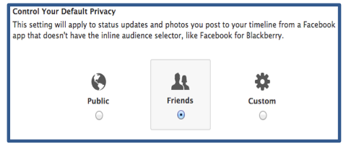 |  |  | Reviewed and customized |  |  |  | Alyssa has left her privacy settings wide open. Everything you post isn’t for everybody. It is really important to know what personal information, posts, pictures and videos people can see and what they can’t.
Headline  (mini bio) | "Design is not just what it looks like and feels like. Design is how it works." – Steve Jobs |  |  | I am a 17 year old Mac obsessed app developer who loves a great debate and plans on being a future radio superstar. |  |  |  | Along with your profile picture and your location, your mini bio is the first chance you get to introduce yourself. While this quote is not a bad idea, because it reflects her passions in an abstract way, the makeover gives you a much better idea of who Alyssa is. It also shares a bit of her personality.
Detailed Bio  (about section) |  | Hey everyone!  This is where I share everything about me and what's going on in my life. |  |  | Hey everyone!  My name is Alyssa Ramos. I'm a 17 year old app developer from Ontario. I'm obsessed with anything Mac, terrified of cats and I recycle almost everything. I’m on my high school debate team so I am always up for a good discussion. You can hear my voice every weekday morning at 9:05 because I’m on the student announcement crew. |  |  |  | Most people don’t take the time to write a bio. Alyssa let readers know what they can expect to see on her social media profile but it's not very specific. In the makeover she shares a bit more information about her experience, talent and skills.  The detailed bio also gives Alyssa a great way to stand out from other applicants whether for an internship or a scholarship.
For each of the following posts, we decide if Alyssa should Keep It OR Delete It 
Social Media Posts |  |  | “I can’t believe that she would do that to me!!!! I can’t stand her I am sooooo going to get her back!” |  |  |  | We get it. Not every day is a good day. Things happen at school, but Alyssa has to keep her private drama out of the public eye. If a potential employer saw her post, they may think she is argumentative or hard to get along with.
Photos from the bake sale |  |  | 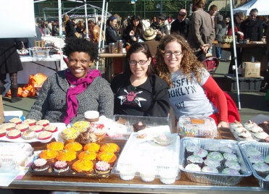  "Woot Woot! I am so excited. It was a long day but we raised a lot of $$$ to support the Red Cross." |  |  |  | Always "publically" share a few pictures of you volunteering. Potential employers, other volunteer organizations and post-secondary institutions love to see this.  Through Alyssa's picture and comment, you get the impression that she has a great heart; she's a hard worker and is dedicated to helping others. All great qualities that people want to hire.

Status Update | Seriouzly! I cant beeeelieve how much scince hmwrk we hav!!! Sooooo ov3r loded 2dayyyyyy! |  | What’s a little spelling mistake? Well for starters employers and volunteer organizations may think that Alyssa doesn't have the skills needed to send an error free email to their clients or other staff.
 | That party was #%&ing bomb! |  | Swearing is a definite turn off to most organizations and so is excessive partying. It’s okay to show that you have fun and even go to social events. Just be careful of what you share.
Link to an interesting blog post related to the career she wants to get into. | Check out this great article I just read about developing an iPhone app. It’s not as hard as you might think!  How to create your first iPhone app   |  | By sharing links and articles about her career interests, Alyssa lets her network know that she is passionate about her future and she is investing her time in learning more about it.
Liked & followed & subscribed to organizations she supports and companies she may want to work with. |   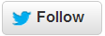   |  | This is an excellent move by Alyssa. By connecting with companies, schools and volunteer organizations on their social media channels, it shows them that she's interested.  She'll be able to learn more about their programs, products and/or services. This is a great way to prepare for an interview.

Image credits: Creative Commons Attribution:
Dog: Aussiegal photostream
Woman: Parker Knight photostream
Bake sake: Rachel from Cupcakes Takes the Cake photostream

Your Turn

- What do you think of Alyssa’s social media makeover?
- Write two or three paragraphs describing what you like or don’t like about Alyssa’s social media and how you can apply some of these tips to your own profile.

Are you ready to create your own social media content? Check out the worksheet on the next page to get started.

Creating Social Media Content
Your Name: _______________________________________
Date: __________________________

- Imagine you are applying for your dream job or volunteer opportunity. Write down 5 content ideas you could create that might attract your dream employer. Go back to your bio if you need some inspiration.
Example: Share a picture of you crossing the line at a fun run to demonstrate your commitment to participating in community events.
- Which one is your best do-able idea? Why do you think it is the best idea? Write your answers below. Explain your decision to a partner.

- Describe the process you will use to create your content piece step-by-step. Discuss your plan with a partner.
- Which social media website(s) will you share your content on? Explain for each one why you picked that site.
- Now that you have decided which skills you are tapping into, the process you will use and where you will share it, bring your idea to life. Create your content piece that will help you and your skills get noticed. Write your content below.

One more step!
No matter what you create, there are a few universal tips that apply to social media content to make sure it gets noticed. Before you publish something to the web, ask yourself the following questions:
Did you:

- Write a title that makes people want to read the content?

- Include keywords in your headline and in your body content? (Keywords are the search terms people would use to find info about the subject you are writing about.)

- Proofread it? Readers notice spelling and grammar errors.

- Showcase your transferable Essential Skills and work habits?

- Include links so people can find out more about you or link to anything you may have referenced in your article?

- Create a positive impression of yourself?

- Tell the truth? Creating a positive impression is important but the information still needs to be true. It is easy for employers, colleges/universities and volunteer organizations to check.

- Get permission for everything you plan to post including testimonials and photographs?

Before you post anything it is also important to remember that just like driving a car, cooking a meal, or learning any new activity, there are things you can do to make sharing information online much safer.

Collect Great Social Proof
What is “social proof”?

Imagine you want to buy a new cell phone or video game. What do you do before you make the purchase? You probably go online to read what other people have said about the particular model you are interested in.
Even though you don’t know the people who’ve left the reviews, their opinions are very powerful and will influence your final decision. These reviews, comments, testimonials, star ratings and even pictures of celebrities using the product are often referred to as social proof.
Social proof can be applied to people as well as products.
Social proof about you can help you get a job, become a volunteer or get into a special program. For example, if a potential employer were to read or watch videos of people talking about your positive attitude and job performance, imagine how that could help you stand out.
Social proof can be shared at interviews by bringing a printed copy. You can share it on social media websites through links to your résumé, bio, or cover letter, and on your blog or website.
Check out the next pages for more tips on how to collect great social proof.

How to Collect Great Social Proof

Asking for social proof takes time, practice and careful thought. Ideally you want social proof that showcases a variety of your transferable Essential Skills and work habits.
The following steps can help get, and keep, you on the right track.
Start with what you have
- Do you have letters of reference from an employer or a volunteer opportunity?
- Did you realize that your OSP Work Plan and OSP Community Involvement Worksheet have been signed by a workplace supervisor, authenticating them as workplace references? These kinds of records provide great social proof of your Essential Skills and work habits – skills that employers say are important for success in the workplace.
Here are some things to keep in mind as you collect social proof.
Ask the right people
Get Permission

If you plan to share your social proof through social media or even on paper – and you will – you MUST have permission in writing from the people who talked about you if you are going to refer to them by name OR share images of them.
- Be sure the people you ask can speak on camera or write about you in a positive way. Consider your teacher, volunteer supervisor or manager at work. Avoid using family or friends unless they also have a work-type relationship with you.

Ask the right way
- Ask politely and explain why you are asking. People are often more willing to help when they understand the reasons for it. If the person you are asking is unable to help, remember to thank them for considering your request.

Help them by thinking about what you want them to talk about
- Is there a particular experience or skill area that you would like them to talk about? The person who is doing the testimonial may ask you what you want them to say. Be prepared with a suggestion.
- Refer to all of your OSP records which detail your Essential Skills and work habits demonstrations. Decide which skills to focus on for a particular opportunity. Ideally you want to highlight skills that are particularly relevant for the opportunity you are seeking. This is what we mean when we say these skills are transferable.

Help them by asking when you have their attention
- Avoid asking during the busiest time of the day. Look for the right opportunity and if you are shooting a video testimonial, make sure you are doing it in a quiet place.

Keep testimonials short
- A few sentences or a short video that is less than one minute is best. If someone sends you a long email or talks longer than a minute, edit it down to just the best parts. If you have done a significant edit, send it back to the author to check that they are still happy with it. If it is really good, leave it as is. It’s okay to have a few long ones.

Share a picture of the person who wrote the testimonial
- If possible include both the name and a picture of the person providing the testimonial on your site. This makes a bigger impact and can appear more trustworthy to the person who is reading it. On paper résumés include just the names.

Get in to the habit of asking for social proof
- Plan to get proof whenever the opportunity presents itself. When you are in a work placement or volunteer opportunity create an OSP Work Plan to show how you used your Essential Skills and work habits on-the-job. When you are volunteering always get someone to snap a few pictures or shoot a video of you in action at the event. But remember to get permission from everyone in the photos if you plan to post them to the web. You can also send a polite email request for a testimonial or comment shortly after your volunteer period is complete.

Remember to update your OSP Tracker as you gather evidence of your skills demonstrations. Use the OSP Reflection Sheet to see how your skills can help you achieve your learning and career goals.


There is one social media account that works better than the others on collecting professional social proof: LinkedIn
As you read at the start of this module, some people refer to LinkedIn as the Facebook for career-minded professionals. LinkedIn is a great Website to look for jobs and network with people in the industry you want to work in. You may find more use for it as you gain more experience in the work world.
Once you are “connected” to someone on LinkedIn it is easy to ask them for a recommendation that you can share on your profile. You can also list specific Essential Skills and work habits that your connections can quickly endorse you as having. These recommendations and endorsements are excellent forms of social proof.
With a special University pages section launched in 2013, students ages 14 and older can now create their own LinkedIn profiles and use the site to explore universities worldwide, research career options, check out famous alumni and expand their social networks.
Learn more about how to use LinkedIn at their website www.linkedin.com

Asking for Social Proof
Your Name: _______________________________________
Date: __________________________

Step 1: Write down the names of at least four people you can ask for a testimonial.
Step 2: Beside their names write down what you would like that person to talk about specifically. Use these notes as a reminder when you request the testimonial.
Name 1:
Proof topic/event/Essential Skills and work habits:

Name 2:
Proof topic/event/Essential Skills and work habits:

Name 3:
Proof topic/event/Essential Skills and work habits:

Name 4:
Proof topic/event/Essential Skills and work habits:

Step 3: Now it’s time to think creatively. Describe in detail how you are going to showcase your proof. For example, will you create a Flickr photoset, a PowerPoint presentation for SlideShare, a Facebook album or update your personal blog or paper resume? What are you going to do?

Final Thoughts

Congratulations: you have taken the first step in:  - Creating a great bio to make a great impression.  - Creating content gets you noticed – in a positive way.  - Collecting great social proof to back you up. This will help to show your future employers how amazing other people think you are.  Remember to file your social proof in your Individual Pathways Plan (IPP) and reflect on how the activities in this module can help you find meaningful answers to the following four education and career/life planning inquiry questions: Who am I? What are my opportunities? Who do I want to become? What is my plan for achieving my goals? | 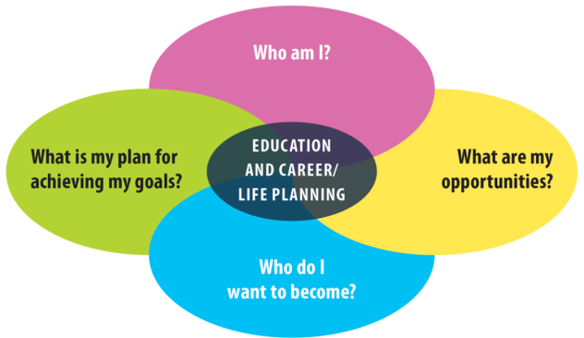

Ready to learn more about using social media to showcase your Essential Skills and work habits to achieve your goals?
Go to OSP Social Media Resource Module 3: Building Your Brand

http://www.washingtonpost.com/sports/highschools/growth-of-social-media-shapes-recruiting-landscape-in-high-school-sports/2012/01/26/gIQA5uQPdQ_story.html

