 | OSP Social Media Resource  Module 4: Building Your Network

In this Ontario Skills Passport (OSP) Social Media Resource module, you will learn how to create, build and use your social media network as an important tool for realizing your personal and academic goals.
Your Individual Pathways Plan (IPP) is an important tool that can help you find meaningful answers to the following four education and career/life planning inquiry questions: Who am I? What are my opportunities? Who do I want to become? What is my plan for achieving my goals?  The questions that are particularly relevant for this module on networking are What are my opportunities? What is my plan for achieving my goals? | 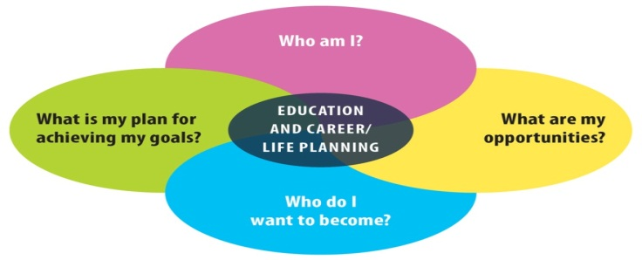

So, what do we mean by “networking”?

Networking is the process of meeting and interacting with individuals who have similar interests in an effort to build relationships that will produce current and future benefits. (Source: YourDictionary.com)
Networking certainly happens face to face but now, more than ever, social media also plays a vital role in the process. Through social media you have access to a tremendous number of people, companies and information that you might never meet otherwise. When you network with a plan, you have the ability to maintain and grow relationships with just a few clicks.

Work Smart: Stay Safe
Social media is a great tool to expand your opportunities for post-secondary education, volunteer work and employment. But like any tool it is important to take precautions to stay safe while you are using it. Before beginning these modules:

- Make sure your parents know what websites you are using before you start any social media networking.
- Check with your teacher or guidance counsellor for any additional school board policies that may apply in your area.
The Kids Help Phone website has some great online safety tips.
You might be thinking, isn’t it a bit too soon to start worrying about building my professional network?  Not at all! Strong relationships don’t happen overnight.  In this Building Your Network module, you will learn how to uncover the valuable connections you already have within your own network.  You will also learn how to find, make and keep exciting new connections.  Complete the Reflection Worksheet and get started. | 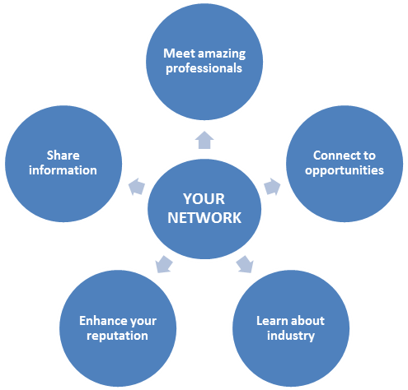

 | Building Your Network: Reflection | 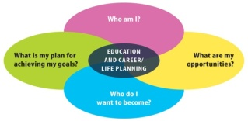
Your Name: _______________________________________
Date: __________________________
- Start with a clear idea of what “social networking” means to you. One way to do that is to use an image or picture. Use the keywords “social networking” to search for an image you feel represents what the words mean (you can use a site like Google Images to filter your search to images only). Copy and paste the image below. Remember to include the URL where you found the image.
Briefly describe why you feel this image is an effective representation of social networking.
- For some people the idea of making professional connections is exciting, while others may feel a bit intimidated by the process. How do you feel? Record your thoughts and feelings below.
- List two specific questions you have about professional networking that you hope to find the answers to as you complete this module.
Growing Your Network

In this section, you will begin the process of growing your personal network by asking yourself four key questions:
?

- What is my goal?
- Who do I already know that can help me reach my goal?
- Who else do I need to know to help me reach my goal?
- How can I make the new connections I need?

Knowing the answers to these questions can help you develop a strategic plan to build a network of people that you can go to for guidance, knowledge, ideas and potential opportunities.
To illustrate how you can tap into your own network, we are going to show you how Phil, a learner in grade 12, answered these questions to create some incredible options to help him build his future.

What is your GOAL?  Always start with your goal then plan for how to get there. Your goal answers the question, “Why are you networking?” Phil’s goal is to be a best-selling author one day.  Who do you ALREADY know?  You may not have a large list of connections yet, but your network is probably larger than you think. Start by reviewing who is connected to your immediate friends and family, as well as your teachers and guidance counsellors.  When Phil started making a list of who he knows, he remembered his friend Ava mentioned her uncle is an editor for a publishing company. Ava’s uncle would be an excellent person to talk to for advice and to stay in touch with.  Who do you NEED to know?  Think about your goal. Who do you need to know to help you achieve it? In Phil’s case, he is having trouble deciding which post-secondary programs to apply for. He has already talked to his English teacher, but he is still unsure and needs answers ASAP. Connecting online with the professors, teaching assistants or current students in the various programs to get “insider” information may help him narrow down his choices.  How can you make those connections?  That’s what this module will help you learn to do. | 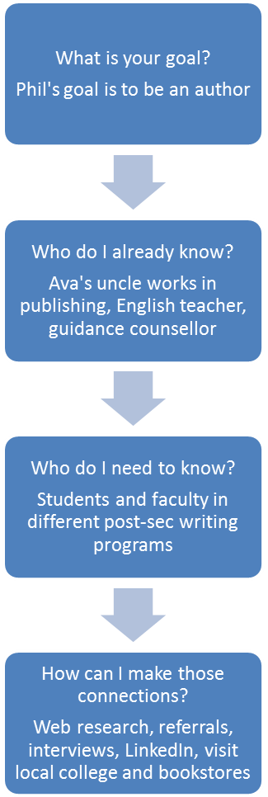
Throughout your life you will continue to meet many great people face to face and online. Never discount a connection because they aren’t into what you want to do in the future. You never know who you may be able to connect them with. Networking is not just about what you can get, it’s about what you can give.
Now, it’s time to ask yourself this same set of questions. Record your answers on the Growing Your Network Worksheet.
Growing Your Network
Your Name: _______________________________________
Date: __________________________
- Why are you networking? What is the goal you are trying to reach?
- List three people you already know who can help you reach your goal. Identify what it is that makes them a good connection and how they can help you.
- Identify three people you don’t know yet but you believe can help you achieve your goal and why you want to connect with them. (Position titles are fine if you don’t have names.)
- List three ways you can make a connection with the people or types of people you need to know.
Making New Connections

As we saw in the Growing your Network activity, your network may be larger than you think.
The easiest way to gain a new connection is to be introduced by a friend or family member. Referrals from individuals who actually know you are particularly effective. You can do this by simply asking them if they know anybody who has the skills, experience or connections that you are looking for. Or you can proactively review their online connections, friends and followers and create a list of the ones you want to meet.
When you are ready to look beyond your immediate network here are a few ways you can use your research skills to uncover some fantastic new contacts.
 | Review corporate social media accounts  Links to corporate social media accounts are usually posted on the company’s Website. They often follow their own employees and thought leaders in their industry. Search their “About Us” or “Our Team” pages to find related accounts for individuals in the organization including Twitter and Facebook.
Go through industry blogs and Websites  Industry blogs and websites are great places to find professional connections. They feature articles written by experts in their field. At the end of an article, the author’s name is usually listed along with the links to their social media accounts, websites and/or their email address. Don’t forget to look at the people who make insightful comments on the articles. They often leave links that go back to their own website and/or social media accounts that you can follow. |  |  |   
 |  | Use a search engine  Use your favourite search engine to find new connections or search directly inside the social networks. If you don’t have a specific name, you can search a position title + company name and the social network name. Including a location in your search also helps to narrow down your results.
Search LinkedIn for professional connections  When it comes to networking, LinkedIn deserves a special mention. According to their website, it is the world’s largest professional network. The LinkedIn website has a great search engine. Once you find a person’s profile, you can see what experience they have and review their career path for clues on how they got to where they are today. With a special University pages section launched in 2013, students 14 and older can now create their own LinkedIn profiles and use the site to explore universities worldwide, research career options, check out famous alumni and expand their social networks. |  |  |  | 
In the next activity you will use these research strategies to locate the connections you identified as ones you need to know who can help you reach your goal.
Find Your Connections
Your Name: _______________________________________
Date: __________________________
In the previous activity you identified three people (or positions) who you believe can bring you closer to your goal. In the space below, list the three and then try to locate them online using any of the strategies outlined in this module. Important: Do NOT contact them yet. The next activity will include advice for making an effective and professional connection.
- Name/Title:
What research strategies did you use to find the person?

Describe how easy or hard it was to find the person.

- Name/Title:
What research strategies did you use to find the person?

Describe how easy or hard it was to find the person.

- Name/Title:
What research strategies did you use to find the person?

Describe how easy or hard it was to find the person.

Making the Connection
Now that you have located the new connections you believe will help you reach your goal, it’s time to reach out and connect. When you send your request, you should always include a short message with it. The message should be genuine, personalized and highly specific. It will increase your chances of connecting.
Here are five highly effective message types that can help you get connected.
Ask your connections to introduce you
As you discovered in the Growing Your Network activity; you may have more contacts than you think, so use them! Ask people within your network to introduce you to the contacts you are interested in. Make sure you tell them exactly why you want to meet their connection so they know how to introduce you.

An informational interview is not a job interview. It’s an interview with an individual working in a career you would like to learn more about to collect information about a job, career field, industry or company.

Try the informational interview approach
An information interview request is where you ask for advice on how to break into the industry or what it’s like to work/volunteer at their organization. Many people are very happy to share what they know to help a young person succeed when they show initiative.
Nothing available now? Ask about upcoming opportunities
This type of connection request is a great way to show an organization that you are really interested in volunteering/working for them. Remember to include a compelling reason why you want to work with them. Hint: it’s not just because it pays well.
Use sincere flattery
Who doesn’t like a compliment? If you have read, watched or listened to someone’s work and thought they did an awesome job, let them know. Tell them why you are impressed and then let them know that you would like to connect so you can continue to learn through their updates. Admiring their work and accomplishments are great reasons to reach out.
Connect at a personal level
Reality Check
Not all of your attempts to make connections will be successful. The person you are trying to connect with may be busy, going through something personal or simply can’t or doesn’t want to help. Try not to take it personally and instead focus your time, energy and effort on staying in touch and building meaningful relationships with those you have made a positive connection with.
Look for other common ground to talk about besides the professional one. For example, if you are into hiking and one of your professional connections just posted pictures of their latest hiking adventure, comment on it. Share tips and your personal experiences too, if they respond to you.

You are now ready to make your new connections.
Make Your Connections
Your Name: _______________________________________
Date: __________________________
List the three persons you identified as connections you want to make in the spaces below.
Now try and connect with each of them using any of the connection request strategies outlined in this module: personal introduction, informational interview request, upcoming opportunities inquiry, sincere flattery and personal connections. Record your results below.
- Name/Title:
What request strategies did you use?

How effective were they? Is there anything you would do differently?

- Name/Title:
What request strategies did you use?

How effective were they? Is there anything you would do differently?

- Name/Title:
What request strategies did you use?

How effective were they? Is there anything you would do differently?

Keeping Your Connections
Once you make any new connection it is important to keep the connection active.
There are many benefits to using social media including the ability to fairly easily stay connected to people so that you remain top of mind when opportunities come up that might be important for you. Some ways to connect are more general while others allow you to target specific individuals. Mixing both of these strategies can be very effective.

Connecting to everyone
The purpose here is to show up in all of your connection’s feeds regularly. They will get used to seeing your profile and updates and if you share valuable content, they will notice and share it too which will further expand your network.
The content you share will shape their perception of you and the transferable skills, talent and knowledge you possess. Effective ways to stay connected include:
- Share great content you’ve created yourself
- Post valuable articles, videos, podcasts and pictures that reflect your professional goals
- Retweet, share, like and re-blog your connection’s relevant updates.

Connecting to specific individuals
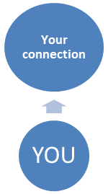
Sharing relevant content and resources directly with someone is an effective way to build or strengthen that specific relationship. Ways to do this include:
- Ask your connections for feedback individually.
- Leave an insightful comment on their blog post.
- Respond to a tweet/post asking for expertise or advice about something they want to buy, watch, find or read; if you know the answer.
The connection request strategies you learned in the previous module can also be used as keep- in-touch strategies too. Don’t be afraid to ask a contact for a personal introduction, information interview or about upcoming opportunities.
Sharing sincere and appreciative feedback also goes a long way. Look for personal
connections and similar passions that are outside of work.

Keep Your Connections
Your Name: _______________________________________
Date: __________________________
Review your current social media connections. Select three individuals that you would like to develop a deeper professional relationship with and complete the table below.
- Name/Title:
What is your goal for this connection?

What active strategies will you use to achieve that goal?

- Name/Title:
What is your goal for this connection?

What active strategies will you use to achieve that goal?

- Name/Title:
What is your goal for this connection?

What active strategies will you use to achieve that goal?

Final Thoughts
Different Communication Styles

How you communicate can be just as important to your connections as what you communicate.
Pay attention to the communication styles of the people in your personal social network. Don’t over share or over communicate with your new connections, even though you are excited to be connected. Look for great opportunities to respond and share strategically.
Watch how and what your connections respond to and try to communicate in a similar way. Some people can post back and forth all day; while others may make time for only one or two responses a day.
If you are having difficulty making and maintaining professional connections review your online activity to see what the reasons may be and adjust your activity accordingly.
As you move through life your social network will become more than just your peers. Always be aware of this fact. You never know who might be considering you for a new opportunity. Keep your social media activity positive and professional – it may be the first thing they see.

Use the information you gathered in this module to help you find meaningful answers to your education and career/life planning inquiry questions. The following two questions are particularly relevant to this module: What are my opportunities? What is my plan for achieving my goals?

Have you completed all four modules in the OSP Social Media Resource? Congratulations!! Don’t be surprised that you have used almost all of your Essential Skills and work habits to complete the activities in this resource.
You are well on your way to using social media safely and effectively to showcase your Essential Skills and work habits and transfer them to everyday life and the next place you go – whether it’s further education, training or the workplace.

